FOOT DRILLS

Exercising the feet is often overlooked; however, they are such an integral part of our everyday life, and there are many muscles, joints, and ligaments that would greatly benefit from intentional exercise of the feet.

Below are six images of feet. Each one is depicting a different foot position that you will maintain while walking – that is the foot drill.
- Each foot drill should be done for one repetition at 25 meters.
- These can be done in socks or bare footed, preferably on a grass surface; however, any flat, clean surface will do.
- Results will be subtle but should be noted in about 2-3 weeks. Different results include but are not limited to a decrease in injuries, improved cornering, and improved jumping ability. Consistent use of these drills will decrease or eliminate shin splints, plantar fasciitis, Achilles tendinitis, and knee problems.
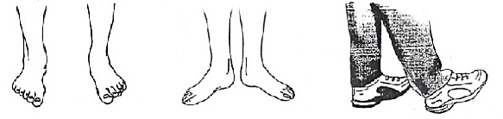
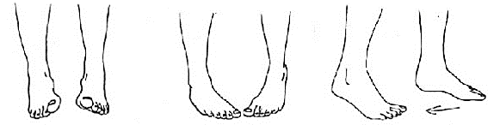
- Total time to complete one repetition of each drill is about 3 minutes - that can definitely fit in your schedule!
Melissa O'Loughlin, DC, CACCP • Maggie Benham, DC
Stephanie Meglino, DC • John Petro, DC • Jessica Berlin, DC
142 Bemis Street Canandaigua, NY 14424
chosenspotchiropractic.com
585.394.2030

Eversion
(Walk on the inside edge of your feet.)
External Rotation
(Walk with the toes pointed outwards.)
Heel Walk Forward
(Walk forward on your heels with toes off the ground.)
Inversion
(Walk on the outside edge of your feet.)
Internal Rotation
(Walk with the toe pointed inwards.)
Tip Toe Backwards
(Walk backwards while up on tip toes.)

